 | 

AI - AUGMENTED BACKEND DEVELOPMENT

Project Title: AI - Weather Wise
Project Type: Team Project
Team Leader:
- Rakshitha. V (222411306)
- NM ID: 74043877CA81CB7A3374073660110BАЗ
Team Members:
- Anu. P (222411297)
- Sandhiya. A (222411307)
- Yogeshwaran. J (222411296)
Class / Year: III B. Sc
Department: Computer Science
College Name: Vivekananda Vision Arts and Science College
College Code: 1737
Semester: 5th
Academic Year: 2026–2027
Guide Mentor Name: Vijay. K (MCA)

🌦️ AI WEATHERWISE
AI-Powered Weather Information and Insights System

📄 Abstract
AI Weather Wise is a web-based weather application that provides current weather information, a 5-day forecast, and AI-based weather insights. It uses the Open Weather API for weather data and Google Gemini AI for simple weather summaries and recommendations. Users can register and login securely using JWT authentication and manage favorite locations. The application is developed using React.js, Node.js, Express.js, MongoDB, and related technologies, with password encryption, API error handling, AI fallback support, and a responsive interface.
Keywords: AI Weather Wise, Weather Application, React.js, Node.js, Express.js, MongoDB, Open Weather API, Google Gemini AI, JWT Authentication, REST API, Favorite Locations, Weather Forecast

1. 📖 Introduction
AI Weather Wise is a web-based weather application that provides current weather information and a 5-day forecast for different cities. It uses the Open Weather API for weather data and Gemini AI for simple weather summaries and recommendations.
Users can register, login securely, and save frequently used cities as favorite locations. The application is developed using React.js, Node.js, Express.js, MongoDB, and related technologies.

2. ⚠️ Problem Statement
Users need simple and understandable weather information for daily activities, travel, college, work, and outdoor planning. AI Weather Wise provides current weather, forecasts, favorite locations, and AI-based insights in one user-friendly application.

3. 🎯 Objectives of the Project
- To provide real-time weather information.
- To provide a 5-day weather forecast.
- To display important weather parameters clearly.
- To provide AI-generated weather insights.
- To provide secure user registration and login.
- To use JWT authentication for protected features.
- To allow users to save and manage favorite locations.
- To provide proper API and AI error handling.
- To create a responsive user interface.

4. 🌍 Scope of the Project
The project includes:
- City-based weather searching.
- Current weather information.
- 5-day weather forecasting.
- AI-based weather insights.
- User registration and login.
- Password encryption and JWT authentication.
- Favorite location management.
- MongoDB-based user and location storage.
- Responsive web interface.
Future versions can include weather maps, notifications, automatic location detection, historical data, and advanced AI features.

5. 💻 Technologies Used
Frontend: React.js, JavaScript, HTML, CSS, Axios, Vite
Backend: Node.js, Express.js, JavaScript, Axios
Database: MongoDB, Mongoose
APIs and AI: Open Weather API, Google Gemini AI
Security and Backend: JWT, bcryptjs, dotenv, CORS
Development Tools: Visual Studio Code, MongoDB Atlas, Thunder Client, Node.js, npm

6. 🏗️ System Architecture
AI Weather Wise follows a client-server architecture.
The React frontend sends requests to the Node.js and Express.js backend. The backend communicates with MongoDB for user and favorite-location data and with Open Weather API for weather information. Gemini AI processes weather data to generate AI insights.
Architecture Flow: User → React Frontend → Express Backend → MongoDB / Open Weather API / Gemini AI → Backend → React Frontend → User

7. 🧩 System Modules

7.1 👤 User Registration Module
Allows new users to create an account using name, email, and password. Passwords are encrypted using bcryptjs before storage.

7.2 🔐 User Login Module
Allows registered users to login using email and password. After successful login, a JWT token is generated for authentication.

7.3 🛡️ Authentication and Security Module
JWT middleware protects user-specific operations such as adding, viewing, and removing favorites. Invalid or expired tokens are rejected.

7.4 🌤️ Weather Search Module
Users can search for a city and view city/country, temperature, feels-like temperature, weather condition, humidity, wind speed, pressure, cloudiness, visibility, sunrise, and sunset.

7.5 🤖 AI Weather Insight Module
Gemini AI generates simple weather summaries and recommendations. If the Gemini service or quota is unavailable, a fallback message is displayed while weather information remains available.

7.6 📅 5-Day Forecast Module
The application retrieves forecast data from Open Weather API and displays date, weather condition, weather icon, temperature, humidity, and wind speed. The dates are displayed as Today, Tomorrow, and corresponding weekday dates.

7.7 ⭐ Favorite Locations Module
Logged-in users can add favorite cities, view saved locations, select a favorite city to load weather, and remove favorite locations. Duplicate locations are prevented.

7.8 📱 Responsive User Interface Module
The React and CSS interface provides navigation, search, weather cards, forecast cards, authentication forms, favorites, AI insights, and a footer. The design supports desktop, tablet, and mobile screens.

8. 🗄️ Database Design
MongoDB is used to store user and favorite-location data.

👤 User Collection
- Name
- Email
- Password
- Role
- Created date
- Updated date
The email field is unique.

📍 Location Collection
- User ID
- City
- Country
- Created date
- Updated date
A unique combination of User + City + Country prevents duplicate favorite locations.
Mongoose is used for database operations.

9. 🔗 API Endpoints

🔐 Authentication
POST /api/auth/register — Registers a new user.
POST /api/auth/login — Authenticates a user and returns a JWT token.

🌤️ Weather
GET /api/weather?city=CityName — Retrieves current weather.
GET /api/weather/forecast?city=CityName — Retrieves the 5-day forecast.

⭐ Favorites
POST /api/locations — Adds a favorite location.
GET /api/locations — Retrieves favorite locations.
DELETE /api/locations/:id — Removes a favorite location.
Location endpoints require valid JWT authentication.

10. 🏛️ MVC Architecture
The backend follows an MVC-style structure.

📦 Models
- User.js
- Location.js

⚙️ Controllers
- authController.js
- weatherController.js
- locationController.js

🛣️ Routes
- authRoutes.js
- weatherRoutes.js
- locationRoutes.js

🛡️ Middleware
- authMiddleware.js for JWT verification.

🤖 Services
- geminiService.js for Gemini AI communication.
This structure makes the project organized and easier to maintain.

11. 🚨 Error Handling
- Empty city search.
- Invalid city names.
- Missing API keys.
- Weather API errors.
- Duplicate registration.
- Incorrect login credentials.
- Missing JWT token.
- Invalid or expired JWT token.
- Duplicate favorite locations.
- Missing favorite locations.
- Gemini AI quota or service failure.
If Gemini AI is unavailable, weather information continues to be displayed.

12. 🧪 Testing

🔐 Authentication
- Registration — Passed
- Duplicate registration — Passed
- Login — Passed
- Wrong password — Passed
- JWT authentication — Passed
- Missing/invalid token — Passed
- Logout — Passed

🌤️ Weather
- Valid city search — Passed
- Empty search — Passed
- Invalid city — Passed
- Current weather — Passed
- Weather details — Passed
- 5-day forecast — Passed

⭐ Favorites
- Add location — Passed
- Duplicate prevention — Passed
- View favorites — Passed
- Select favorite city — Passed
- Remove favorite — Passed
- Unauthorized access — Protected

🤖 AI
- Gemini integration — Implemented
- AI quota fallback — Passed

🖥️ User Interface
- Navigation — Passed
- Search bar — Passed
- Clear button — Passed
- Login/Register — Passed
- Password visibility — Passed
- Responsive interface — Implemented

13. ✅ Advantages
- Simple and user-friendly interface.
- Real-time weather information.
- 5-day weather forecast.
- AI-generated weather insights.
- Secure authentication.
- Favorite location management.
- Responsive design.
- API and AI error handling.
- Modular backend structure.
- Easy to maintain and extend.

14. ⚙️ Limitations
- Requires internet connectivity.
- Weather data depends on Open Weather API.
- AI insights depend on Gemini API availability and quota.
- Search is mainly city-based.
- Advanced weather maps and historical data are not included.

15. 🚀 Future Enhancements
- Automatic current-location detection.
- Interactive weather maps.
- Hourly weather forecast.
- Historical weather data.
- Severe weather alerts.
- Weather notifications.
- Multiple language support.
- Voice-based weather search.
- Advanced AI recommendations.
- PWA/mobile application.
- Weather charts and graphs.
- Air-quality information.

16. 🔗 Project Links
🎥 API Testing Video: https://drive.google.com/file/d/1s22RKTg8SKs6ACc8QgPBSZzFYHongl0K/view?usp=drivesdk
🎬 Demo Video: https://drive.google.com/file/d/1ji0o34D3ofx7OlNAjr-5oNaWWcIa-3hj/view?usp=drivesdk
💻 Source Code – GitHub: https://github.com/rakshithavemala91-design/AI-WeatherWise.git

17. 📷 Output Screenshots
Screenshot 1
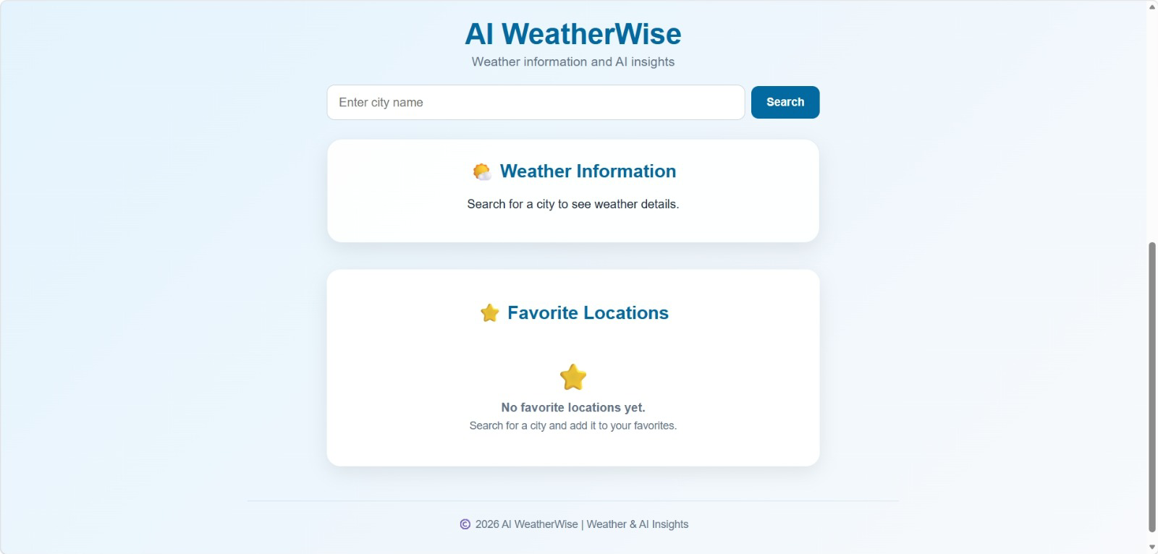

Screenshot 2
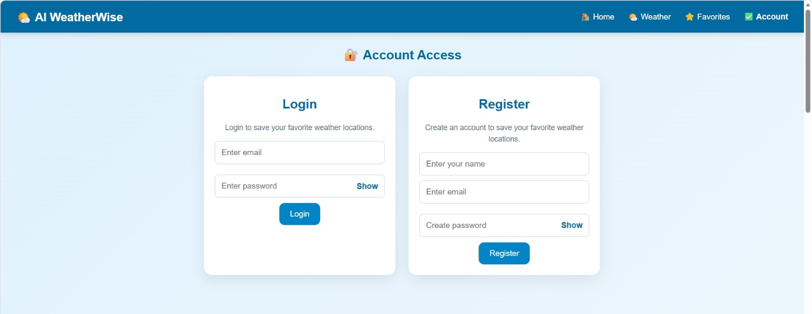

Screenshot 3
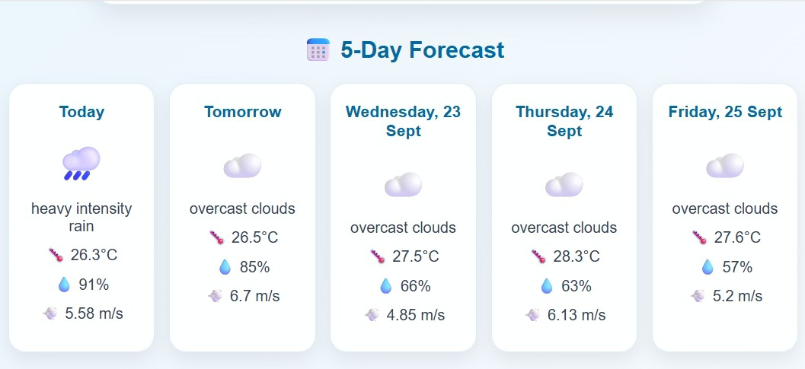

Screenshot 4
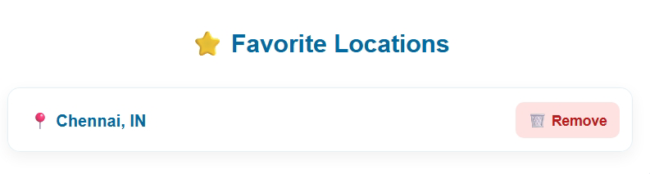

Screenshot 5
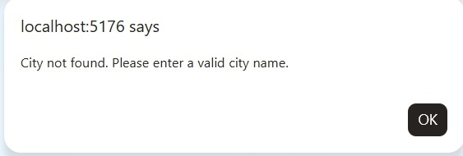

Screenshot 6
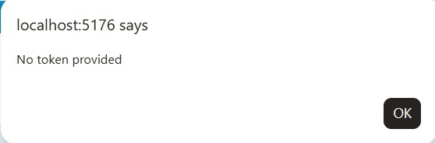

Screenshot 7
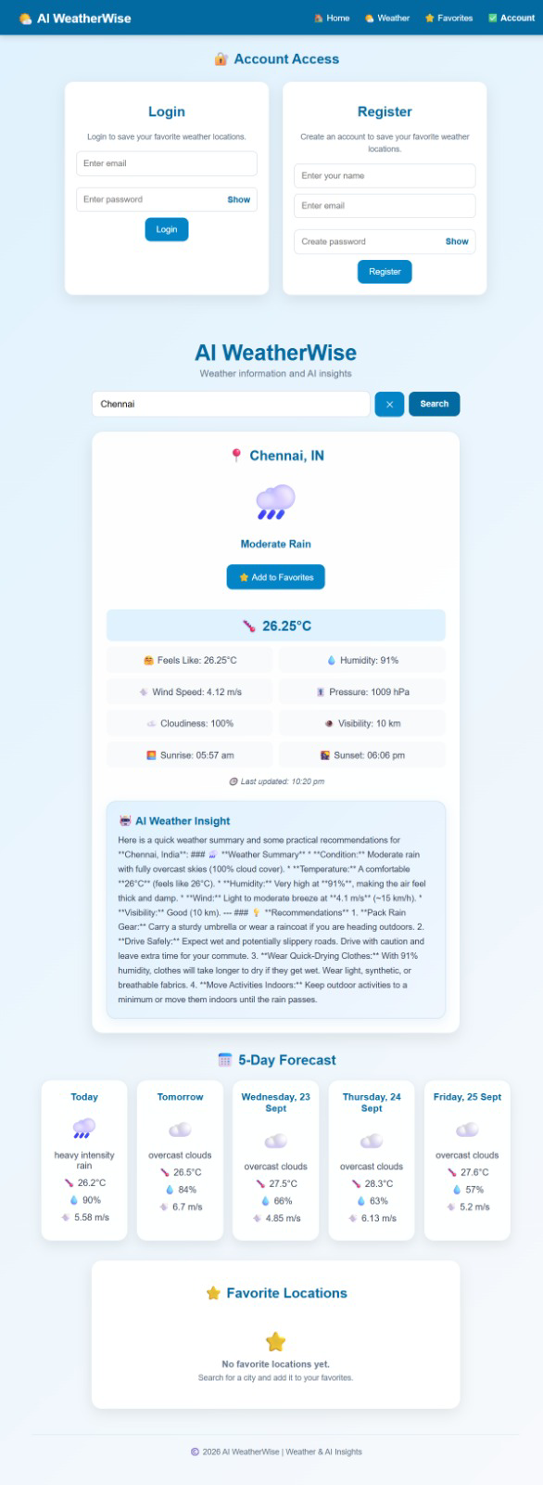

18. 🏁 Conclusion
AI Weather Wise successfully combines React.js, Node.js, Express.js, MongoDB, Open Weather API, and Gemini AI to provide a practical weather application.
The system provides current weather information, a 5-day forecast, AI-based insights, secure authentication, and favorite location management. It also demonstrates REST API integration, database management, JWT authentication, password encryption, MVC architecture, error handling, and responsive web design.
The project provides a strong foundation for a modern weather application and can be further enhanced with advanced weather, location, notification, and AI features.

